**→ What is median denoising filter :**

1. **Read our images and convert it into floating point value :**

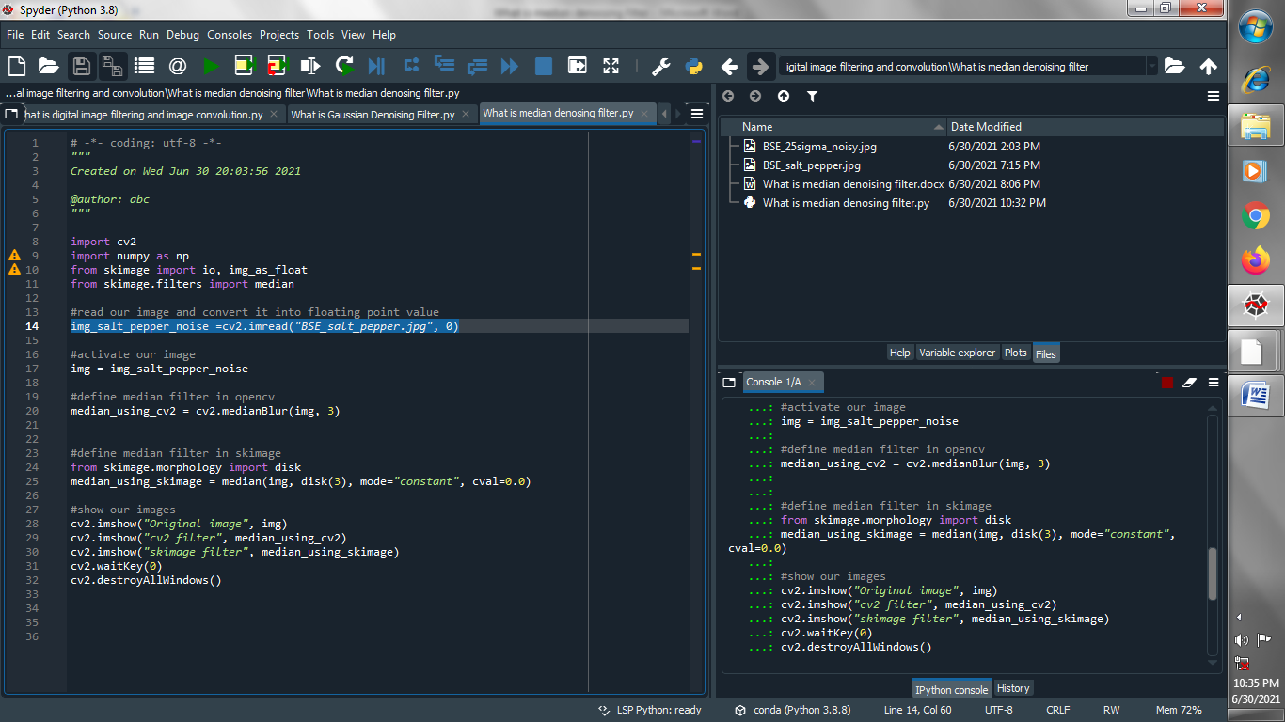

1. **Activate our images :**

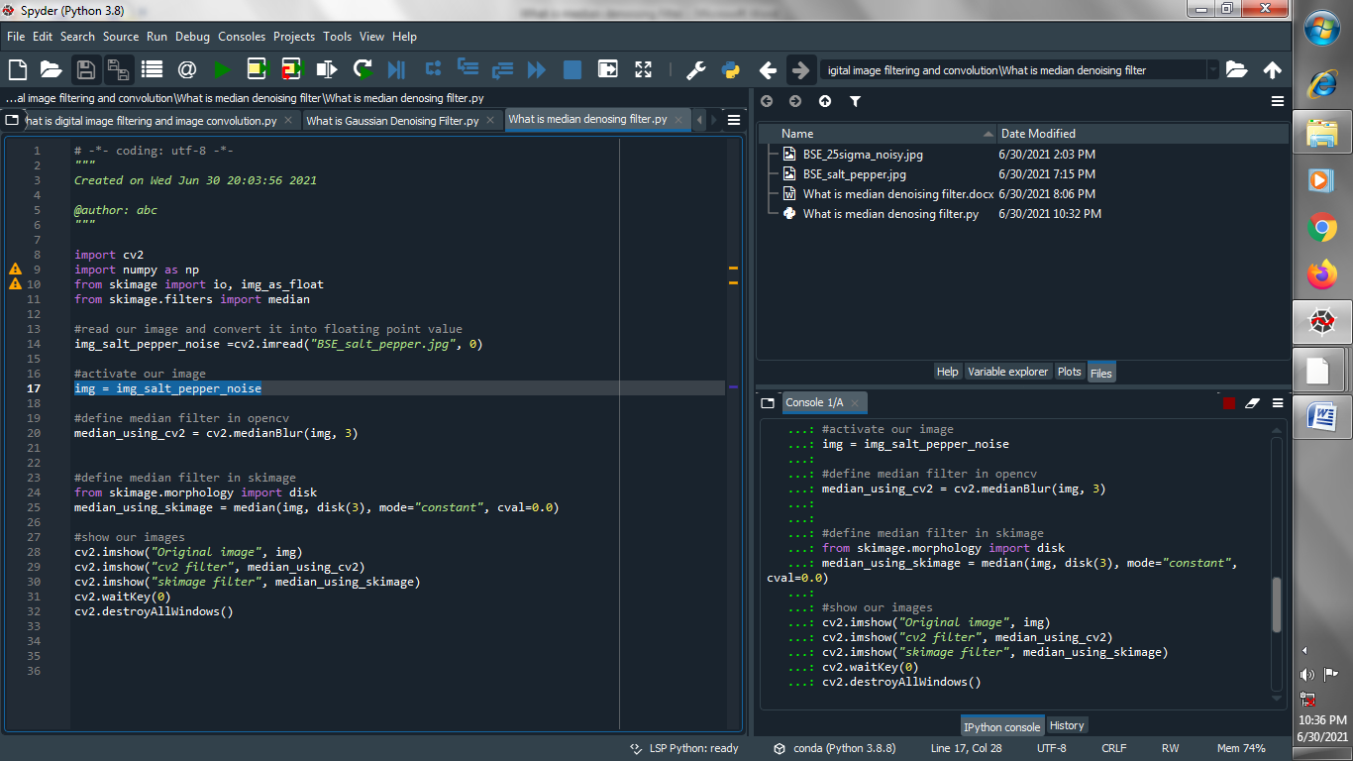

1. **Define median filter using opencv :**

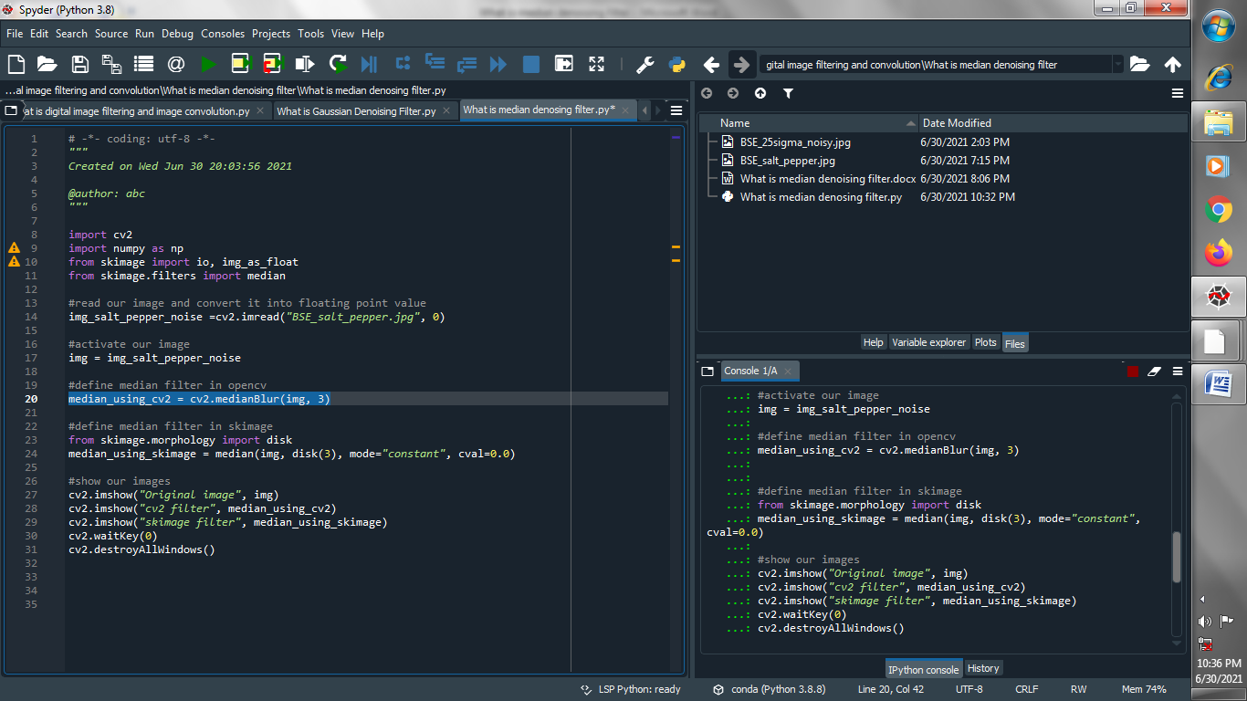

1. **Define median filter using skimage :**

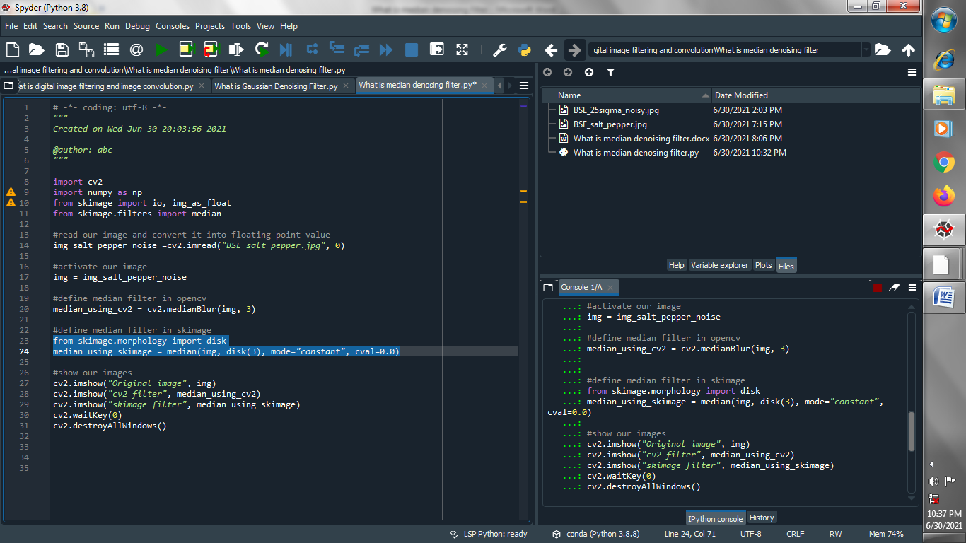

1. **Show all images :**



**Output :**

**Original image :**

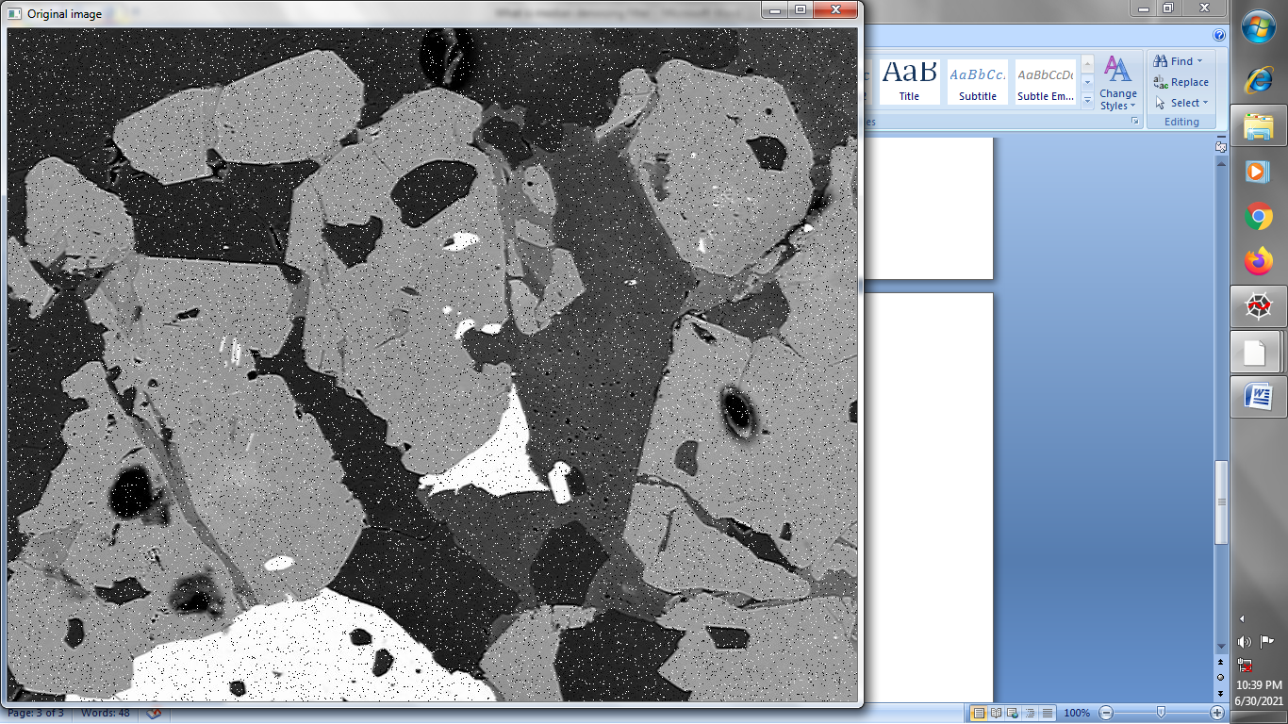

**CV2 FILTER image :**

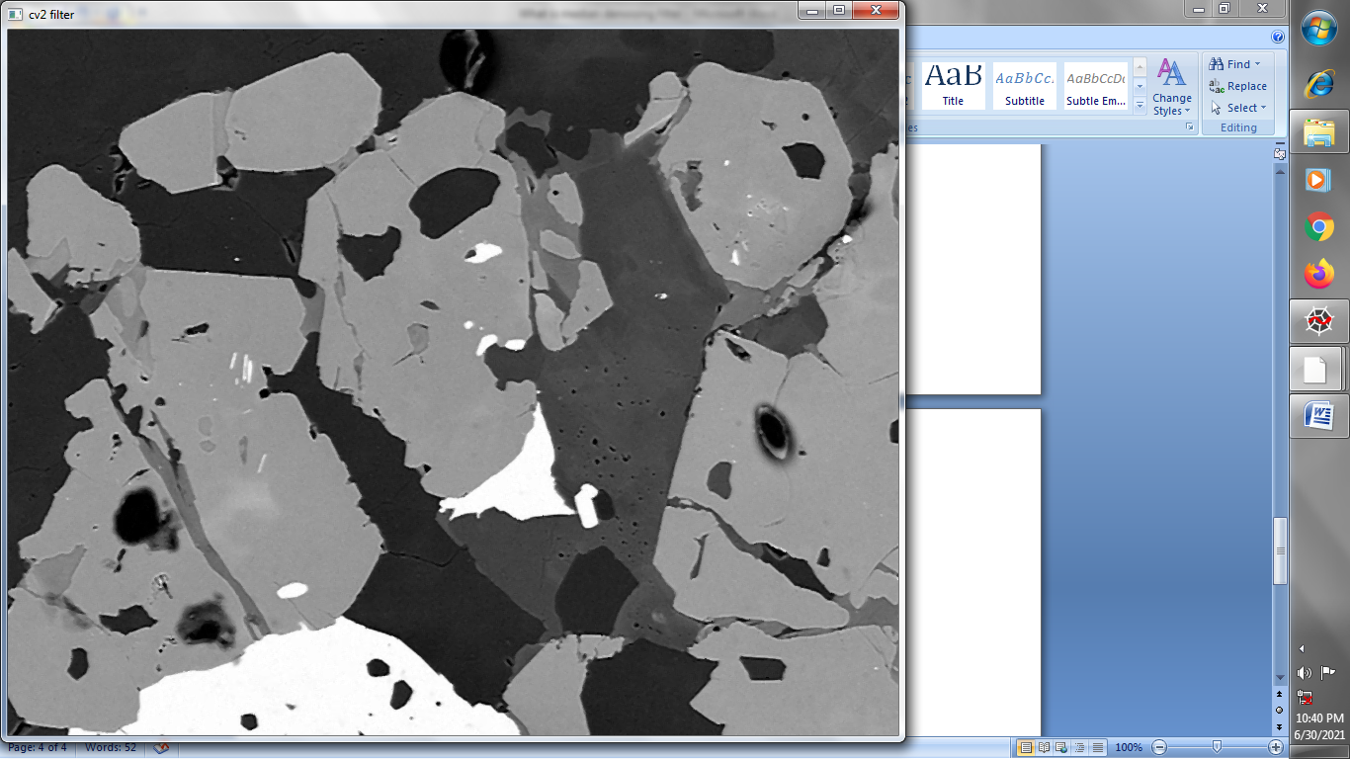

**SKIMAGE FILTER image :**

